Packet Tracer - Troubleshoot WLAN Issues

|  |  |
| --- | --- |
| **Name:** | Danica Marie Dumalagan |
| **Date:** | April 29, 2023 |

# Addressing Table

| Device | Interface | IP Address |
| --- | --- | --- |
| Home Wireless Router | Internet | DHCP |
| Home Wireless Router | LAN | 192.168.0.1 |
| R1 | G0/0/0.10 | 192.168.10.1/24 |
| R1 | G0/0/0.20 | 192.168.20.1/24 |
| R1 | G0/0/0.200 | 192.168.200.1/24 |
| R1 | G0/0/1 | 172.31.1.1/24 |
| SW1 | VLAN 200 | 192.168.200.100/24 |
| LAP-1 | G0 | DHCP |
| WLC-1 | Management | 192.168.200.254/24 |
| RADIUS Server | NIC | 172.31.1.254/24 |
| Admin PC | NIC | 192.168.200.200/24 |
| Web Server | NIC | 203.0.113.78/24 |
| DNS Server | NIC | 10.100.100.254 |
| Home Admin | NIC | DHCP |
| Laptop | NIC | DHCP |
| Laptop1 | Wireless0 | DHCP |
| Laptop2 | Wireless0 | DHCP |
| Tablet PC | Wireless0 | DHCP |
| Smartphone | Wireless0 | DHCP |

# WLAN Information

| WLAN | SSID | Authentication | Username | Password |
| --- | --- | --- | --- | --- |
| Home Network | HomeSSID | WPA2-Personal | N/A | Cisco123 |
| WLAN VLAN10 | SSID-10 | WPA-2 PSK/Personal | N/A | Cisco123 |
| WLAN VLAN 20 | SSID-20 | WPA-2 802.1x/Enterprise | user2 | User2Pass |

# Objectives

In this activity, you will troubleshoot various issues in home wireless and enterprise wireless networks.

* Troubleshoot wireless LAN connectivity issues in a home network.
* Troubleshoot wireless LAN connectivity issues in an enterprise network.

# Background / Scenario

Now that you have learned how to configure wireless in home and enterprise networks, you need to learn how to troubleshoot in both wireless environments. Your goal is to enable connectivity between hosts on the networks to the web server by both IP address and URL. Connectivity between the home and enterprise networks is not required.

To access the Home Wireless Router, the username and password is **admin**.

The WLC management interface username is **admin** and the password is **Cisco123**.

# Instructions

## Troubleshoot the Network

**Note**: You will only be troubleshooting the Home Wireless Router, WLC and wireless host devices in this activity.

### Test connectivity.

* + - 1. Test connectivity between the various wireless hosts and the web server by both IP and URL **www.netacad.pt**.
      2. Record the hosts that cannot access the web server in the table in Step 2.

### Investigate issues and record findings.

* + - 1. Investigate the connectivity issues with each host. Issues may be with the host configuration, or with other wireless network components.
      2. Complete the table.

| Device | Network  Home/Enterprise | Issue | Remedy |
| --- | --- | --- | --- |
| **Tablet PC** | **Home** | **IP Configuration: Static** | **IP Configuration: DHCP** |
| **Tablet PC, Smartphone, Laptop, Home Admin** | **Home** | **Cannot access URL of server** | **Static DNS 1: 10.100.100.254 Tablet PC: ipconfig /renew Smartphone: ipconfig /renew Laptop: ipconfig /renew Home Admin: ipconfig /renew** |
| **WLC** | **Enterprise** | **Wireless VLAN 20 is not enabled.** | **Wireless VLAN 20: Enable** |
| **WLC** | **Enterprise** | **Wireless VLAN 10 Authentication Key Management: 802.1x** | **Wireless VLAN 10 Authentication Key Management: PSK (Cisco123)** |
| **Wireless Router** | **Home** | **Internet Connection type: Static** | **Internet Connection type: Automatic Configuration - DHCP** |
| **Laptop 2** | **Enterprise** | **Cannot connect to VLAN 20** | **Profile Login Name: user2 Password: Cisco123** |

## Fix Issues

Make changes to the device configurations so hosts can achieve connectivity with the network. Test to ensure all hosts can reach the communication goal of connecting to the web server by both IP address and URL.

## Post your screenshots

Close Configuration Window for S2

On the PT Activity window, make sure that the completion grade is **100%**. Click on the **Check Results** button and select the **Assessment Items** tab. Take a screen shot of the whole window, showing the table of assessment items, and the score/item count. Own your photo by placing a watermark on your photo with your name and USC ID Number. Paste your screenshot below:

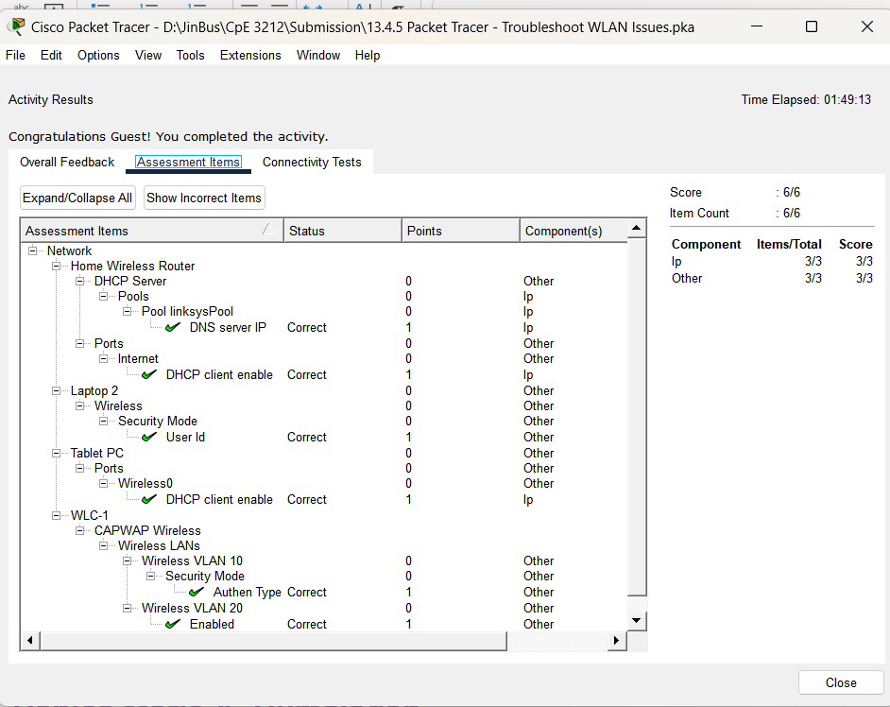

**Danica Marie A. Dumalagan**

**18103276**

End of document